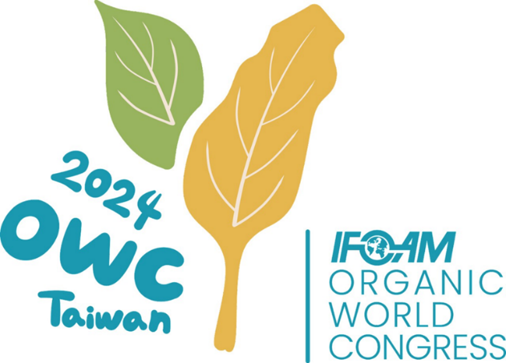

**Sponsorship Plan**

One of the Most Important Events

Around the World:

2024 IFOAM Organic World Congress

November 30th to December 6th

Held for the First Time in Taiwan

at Nanhua University

**TABLE OF CONTENTS**

I. Introduction 2

II. How to Become a Sponsor 3

III. Potential Sponsor Benefits 4

IV. Implementation plan 4

V. Schedule 7

VI. Conclusion 7

# Introduction

1. **Event Overview**

The Organic World Congress (OWC) is a global organic agriculture conference hosted by the International Federation of Organic Agriculture Movements (IFOAM) and is held every three years. Since its establishment in 1972, IFOAM has been committed to promoting the sustainability, environmental friendliness and social equity of organic agriculture, and setting global standards for organic agriculture. OWC is the world's largest organic agriculture event, bringing together experts, scholars, farmers, policymakers and relevant stakeholders from all over the world to discuss the latest developments, challenges and opportunities in organic agriculture. The goal of the conference is to promote exchanges and cooperation in global organic agriculture, share innovative technologies and best practices, and promote the formulation and implementation of global organic standards.

1. **Event Details**

The 2024 Organic World Congress will be held at Nanhua University in Chiayi County, Taiwan, from November 30 to December 6, 2024. It is expected to attract more than 2,500 participants from around the world, including organic agriculture experts, business leaders, academic researchers, government representatives and NGO members, consumers, teachers and students. This conference will become an important platform to promote the development of organic agriculture in Taiwan and around the world, and also provide participants with a unique opportunity to conduct in-depth discussions on the development of global organic agriculture. Please refer to Appendix 1 for the event planning of this conference.

1. **Sponsorship opportunities**

Sponsorship The Organic World Congress (OWC) provides a unique platform for businesses and organizations to demonstrate their commitment to organic farming and sustainability. Through sponsorship, companies can not only enhance their brand image on the global stage, but also gain direct access to organic farming experts and influencers from around the world. Sponsorship plans include a variety of options, such as event naming, exhibition booths, special lecture sponsorships, digital media exposure, etc. Companies can choose the most appropriate form of sponsorship based on their own needs. Companies participating in the sponsorship will receive comprehensive publicity opportunities from the conference to enhance their visibility and influence in the global organic agriculture community.

# How to Become a Sponsor

1. **Sponsorship Tier**

Companies and organizations that sponsor the Organic World Congress (OWC) can choose the following different sponsorship levels, each level corresponds to different financial or material contributions, and enjoy the sponsorship reward program (as shown in Appendix 2):

1. **Diamond：Sponsorship amount NT$ 3M/ € 90K**
2. **Platinum：Sponsorship amount NT$ 1M/ € 30K**
3. **Gold:** **Sponsorship amount NT$ 500K/ € 15K**
4. **Silver：Sponsorship amount NT$ 300K/ € 9K**
5. **Bronze：Sponsorship amount NT$ 100K/ € 3K**
6. **Sponsorship Program**

We provide sponsorship programs (Annex 3) for companies with specific goals to meet their specific needs. These packages can include cash, supplies such as ingredients, travel, advertising, event-related items, etc., or co-branding opportunities such as launching a specific product or event with OWC. Sponsorship packages will be tailored to the company’s goals and budget to ensure maximum brand exposure and engagement.

1. **Application Process**

Becoming a sponsor of OWC is easy, please follow the steps below:

1. **Express Interest**：Potential sponsors can fill out the online application form (Appendix 4) or contact our sponsorship team directly to express interest in sponsorship
2. **Proposal Submission**：Sponsors can submit custom proposals or choose pre-defined sponsorship packages based on their needs.
3. **Approval from IFOAM**：All submitted proposals will be sent to IFOAM (Congress Steering Committee) for approval.
4. **Review and Agreement**：The OWC team will review proposals and negotiate final sponsorship packages with sponsors, followed by drafting sponsorship agreements.
5. **Payment and Commitment**：After the sponsorship agreement is reached, the sponsor makes payment and delivers relevant results according to the agreement.
6. **Contact Information**

For further inquiries or more sponsorship details, please contact our sponsorship contact person (Appendix 5).

# **Potential Sponsor Benefits**

**1.** **Brand Visibility**

* 1. **Brand Promotion:** The sponsor’s brand logo will appear in all event materials, banners, digital platforms and marketing content to ensure that the brand is widely exposed both inside and outside the global organic agriculture field.
  2. **Speaking Opportunities:** Depending on the level of sponsorship, sponsors will have the opportunity to give speeches or hold exclusive workshops during the conference, interact directly with global organic agriculture experts and industry leaders, and share corporate innovations in organic agriculture and sustainable development. and results.
  3. **Booth Space:** Sponsors will have priority access to the main exhibition venues to obtain the best booth locations. This will give your products and services maximum exposure during the event, giving you direct access to potential customers and partners from around the world.

**2. Interaction Opportunities**

* 1. **Exclusive Access:** As a high-level sponsor, you will be invited to OWC’s VIP events to network with key stakeholders. In addition, you will receive privileged access to lecture theaters to participate in high-level discussions with industry leaders.
  2. **B2B Meetings:** Sponsors will have the opportunity to participate in corporate matchmaking meeting arranged by the conference, conduct in-depth discussions with industry leaders, policymakers and potential partners from around the world, and expand business cooperation opportunities.

**3. Marketing and media exposure**

1.1. **Pre-Event Publicity:** Your brand will be included in the pre-event marketing plan, including press releases, social media promotions, email advertising, etc. This will ensure your brand receives maximum exposure within the global organic farming community.

1.2 **Conference Publicity:** During the conference, your brand will continue to be exposed through the official channels of the conference such as social media, official website and electronic press releases. In addition, sponsors can also use the digital display screens in the venue and the conference APP for real-time promotion.

1.3 **Post-Event Publicity:** The sponsor’s brand will continue to appear in post-conference media reports and summary reports to ensure continued extension of brand exposure.

# ****Implementation plan****

**For Sponsor:**

**1. Onboarding**

**1.1 Meet to discuss goals, expectations and timelines**

**At the beginning of the cooperation, arrange an initial meeting with the sponsor to clearly discuss the main goals of the sponsorship, expected results and the schedule of activities. This will ensure that the sponsor's needs are met and establish the direction of the partnership for both parties.**

**1.2 Provide sponsorship solutions**

**Based on the sponsor's level and needs, a complete sponsorship package including sponsor logo, banner design, digital assets, etc. is provided. These resources will help sponsors effectively engage in event branding and ensure consistency and exposure of their brand across all related events.**

**2. Regular Updates**

**2.1 Update Event Preparation and Sponsorship Results Monthly**

Conduct regular monthly meetings or communications with sponsors to provide updates on event preparation progress and sponsorship results. These updates will include details of upcoming events, progress on sponsor engagement plans, and matters that may require further assistance from sponsors.

2.2 **Coordinate Brand Promotion Content**

Work closely with sponsors to ensure branding at events meets both parties’ standards. This includes coordinating and confirming the submission and approval of sponsor logo use, banner designs and other brand assets, ensuring all materials are consistent with the event’s branding and sponsor’s requirements.

**3. Participation in Activities**

**3.1 Arrange Exhibition Space, Speaking Engagements and VIP Visits**

Assist sponsors with arranging booth space at events, ensuring it is in a prime location to maximize brand exposure. In addition, depending on the level of sponsorship, assist in arranging speaking engagements, workshops and VIP visits for sponsors to ensure their participation is fully showcased and valued.

**3.2 Final Report before the Event**

Provide sponsors with a final report prior to the event detailing their role, schedule, expected results from participating in the event, and required considerations. This will help sponsors be fully prepared on the day of the event, ensuring the success and effectiveness of their participation.

**For Organizers:**

**1. Sponsor Group**

**1.1 Designate a dedicated team to manage communications with sponsors**

**Designate a dedicated team to liaise with sponsors to ensure clear communication and the realization of sponsorship rewards. This includes handling sponsor needs and questions and coordinating all matters related to sponsorship.**

**2. Marketing Coordination**

**2.1 Integrate sponsors into all marketing efforts**

**Ensure sponsor’s branding is incorporated into all marketing efforts, including digital, print and on-site materials. This includes scheduling and managing sponsor-related social media posts and press releases to increase the sponsor’s market exposure.**

**2.2 Schedule and manage sponsor-related social media posts and press releases**

**Ensure the sponsor's brand is appropriately displayed in all promotional materials to enhance its marketing impact.**

**2. Conference Logistics**

**3.1 Work closely with sponsors to determine booth details, layout requirements and brand positioning**

**Assist sponsors in determining booth details, layout requirements, and brand placement to ensure sponsors' presentation meets expectations and maximizes the visibility of their brand.**

**3.2 Ensure sponsor visibility at key locations/moments during the conference**

**Ensure sponsors receive maximum brand exposure in key locations and moments during the event.**

**3. Post-Event Activities**

**4.1 Collect feedback from sponsors to evaluate the success of sponsorship**

**After the event, collect feedback from sponsors to evaluate the success of the sponsored event and understand where improvements can be made.**

**4.2 Share post-event reports, including media coverage and attendee data**

**Provide post-event reports, including media coverage and attendee data, to help sponsors understand the overall effectiveness of the event and the exposure of their brand.**

# 、Schedule

1. August to September:

Confirm sponsorship plan

Start contacting potential sponsors

Confirm sponsor list

2. October:

Complete sponsor contract signing

Prepare preliminary marketing materials to ensure early exposure of sponsor’s brand

3. November:

Conduct large-scale marketing campaigns to enhance sponsors’ brand influence

Ensure sponsor’s brand is fully displayed during the event

4. December:

Hold conferences to maximize sponsors’ brand exposure

Post-press conference report summarizing the sponsor’s participation results

# Conclusion

By becoming a sponsor of the 2024 Organic World Congress (OWC), companies will gain significant status and exposure within the global organic farming sector. This is not only an excellent platform to demonstrate corporate social responsibility, but also an effective way to promote your brand and expand your business network. We sincerely invite you to participate and jointly promote the sustainable development of global organic agriculture. We look forward to working with you to create a win-win situation and continue future cooperation opportunities!

**Appendix I: OWC Schedule**

The Pre-Conferences, Tours, Organic World Congress, and the General Assembly of IFOAM – Organics International will be running from the 30th November to the 6th December.

A more detailed program will be provided closer to the event.

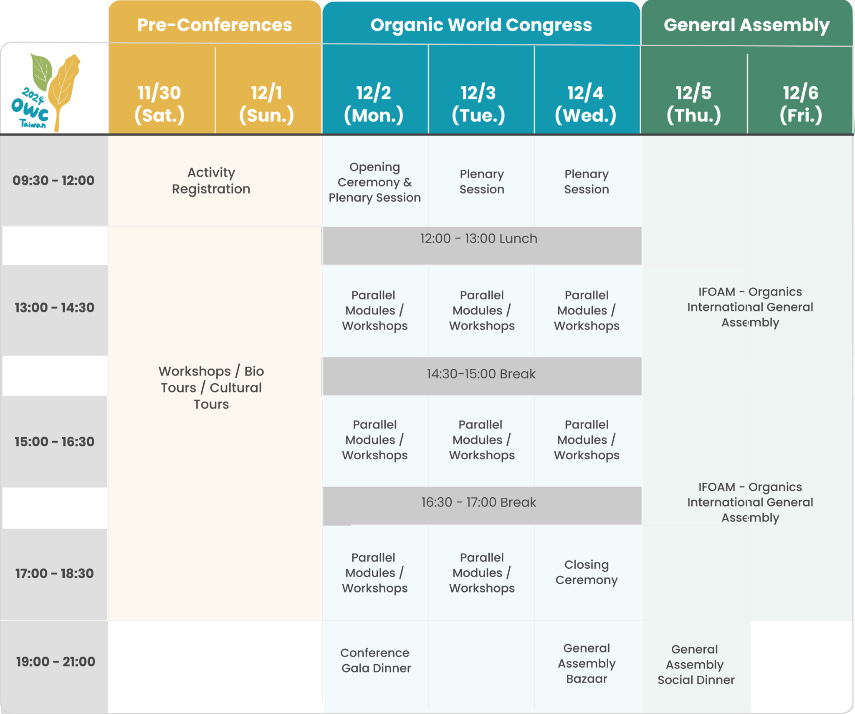

**Appendix Ⅱ、Sponsorship Program**

|  | **Sponsorship Benefits** | **Diamond** | **Platinum** | **Gold** | **Silver** | **Bronze** |
| --- | --- | --- | --- | --- | --- | --- |
|  | **Sponsorship fees in NT$** | **3M** | **1M** | **500K** | **300K** | **100K** |
|  | **Sponsorship fees in €** | **90K** | **30K** | **15K** | **9K** | **3K** |
| 1 | Use the OWC Partner logo on your website and digital/print documents | **✓** |  |  |  |  |
| 2 | Your logo on congress giveaways, where appropriate | **✓** |  |  |  |  |
| 3 | Your support acknowledged in IFOAM - Organics International post-Organic World Congress blog article | **✓** |  |  |  |  |
| 4 | On-site video interview with your organization to be processed and published by IFOAM - Organics International after the OWC | **✓** |  |  |  |  |
| 5 | Issue Certificate of Appreciation on opening ceremony | **✓** | **✓** |  |  |  |
| 6 | A dedicated page on the official OWC website with your key messages | **✓** | **✓** |  |  |  |
| 7 | Your logo/company featured in one session of your choice | **✓** | **✓** |  |  |  |
| 8 | An article or interview with a person of your choice published and shared on IFOAM’s social media | **✓** | **✓** | **✓** |  |  |
| 9 | Logo in IFOAM - Organics International’s monthly newsletter ‘The Insider’ as official OWC sponsor | **✓** | **✓** | **✓** | **✓** |  |
| 10 | Advert space in the event digital brochures provided to all participants | Full Page | Half Page | Quarter Page | One-eighth  Page | Only Logo |
| 11 | Your logo represented across all official OWC on digital and print posters, | **✓** | **✓** | **✓** | **✓** | **✓** |
| 12 | Your logo featured in your sponsor category on the OWC website | **✓** | **✓** | **✓** | **✓** | **✓** |
| 13 | Logo featured in mailers ahead and during the Congress | **✓** | **✓** | **✓** | **✓** | **✓** |
| 14 | Receive digital materials (toolkit) to promote the Organic World Congress and your partnership in your own communications | **✓** | **✓** | **✓** | **✓** | **✓** |
| 15 | Booth at OWC Venue | **5** | **4** | **3** | **2** | **1** |
| 16 | Tickets giving full access to on-site Congress | **10** | **8** | **6** | **4** | **2** |

Note: 1. Sponsors of booth space are requested not to resell the booth to other companies.

**Appendix Ⅲ、Sponsorship Program**

|  |  |  |  |
| --- | --- | --- | --- |
| 1. 現金贊助方案 Sponsorship program by Cash | | | |
| 請勾選  Tick | 編號  Number | 贊助內容Sponsored content | 贊助金額  Sponsorship amount |
|  | A-1 | 鑽石級贊助商**Diamond** |  |
|  | A-2 | 柏金級贊助商**Platinum** |  |
|  | A-3 | 金級贊助商**Gold** |  |
|  | A-4 | 銀級贊助商**Silver** |  |
|  | A-5 | 銅級贊助商**Bronze** |  |
|  | A-6 | 其他金額 |  |
| B. 指定用途贊助方案 Main Sponsorship program | | | |
|  | B-1 | 有機食材、點心 Organic Dood、Dessert |  |
|  | B-2 | 水、咖啡、茶Water、Coffee、Tea |  |
|  | B-3 | 桌椅租借Rented Tables and Chairs |  |
|  | B-4 | 文宣廣告（媒體及實體：機場、高鐵、捷運、台鐵、南華）Social Media |  |
|  | B-5 | 生態文化旅遊Bio Tours/Culture Tours |  |
|  | B-6 | 交通接駁Transportation |  |
|  | B-7 | 印刷費Printing Expenses |  |
|  | B-8 | 保溫瓶thermos |  |
|  | B-9 | 環保杯reusable food ware |  |
|  | B-10 | 表演節目（街頭藝人、音樂、舞蹈、魔術等）Performance(street performance、music、dance、magic,etc.) |  |
|  | B-11 | 攤位桌椅、帳篷、主舞台TRUSS、攤位費等  Tables and Chairs、Tent、Truss、Booths Fee |  |
|  | B-12 | 口譯費Interpretation Fee |  |
|  | B-13 | 電腦及視聽設備Computer and Projector |  |
|  | B-14 | 紀念品Souvenir |  |
|  | B-15 | 其他項目Others | (請自行填入) |
| 贊助總金額 Total Amount | | | NT$ |

註： 1.指定用途贊助之回饋以贊助項目之市價*0.7。

2.贊助方案若已額滿，將與贊助單位商量改換其他項目。

Note: 1. The benefits of main/other sponsorship program please refer to amount from sponsorship package program

2. if the main sponsorship program is full, we will consult with sponsor changing to other content.

**Appendix Ⅳ、Sponsorship Application Form**

|  |  |  |  |
| --- | --- | --- | --- |
| 1. 贊助方案 Sponsorship program | | | |
| 請勾選  Tick | 編號  Number | 贊助內容Sponsored content | 贊助金額  Sponsorship amount |
|  | A-1 | 鑽石級贊助商**Diamond** |  |
|  | A-2 | 柏金級贊助商**Platinum** |  |
|  | A-3 | 金級贊助商**Gold** |  |
|  | A-4 | 銀級贊助商**Silver** |  |
|  | A-5 | 銅級贊助商**Bronze** |  |
|  | A-6 | 其他金額 |  |
| B. 指定用途贊助方案 Main Sponsorship program | | | |
|  | B-1 | 有機食材、點心 Organic Dood、Dessert |  |
|  | B-2 | 水、咖啡、茶Water、Coffee、Tea |  |
|  | B-3 | 桌椅租借Rented Tables and Chairs |  |
|  | B-4 | 文宣廣告（媒體及實體：機場、高鐵、捷運、台鐵、南華）Social Media |  |
|  | B-5 | 生態文化旅遊Bio Tours/Culture Tours |  |
|  | B-6 | 交通接駁Transportation |  |
|  | B-7 | 印刷費Printing Expenses |  |
|  | B-8 | 保溫瓶thermos |  |
|  | B-9 | 環保杯reusable food ware |  |
|  | B-10 | 表演節目（街頭藝人、音樂、舞蹈、魔術等）Performance(street performance、music、dance、magic,etc.) |  |
|  | B-11 | 攤位桌椅、帳篷、主舞台TRUSS、攤位費等  Tables and Chairs、Tent、Truss、Booths Fee |  |
|  | B-12 | 口譯費Interpretation Fee |  |
|  | B-13 | 電腦及視聽設備Computer and Projector |  |
|  | B-14 | 紀念品Souvenir |  |
|  | B-15 | 其他項目Others |  |
| 贊助總金額 Total Amount | | | NT$ |

|  |  |  |  |
| --- | --- | --- | --- |
| 贊助廠商基本資料 Sponsor Company Information | | | |
| 公司名稱 Name |  | | |
| 公司地址  Address |  | | |
| 公司網址  Website |  | | |
| 聯絡人姓名  Contact |  | 職稱  Job Title |  |
| 連絡電話  Contact number |  | 電子信箱  Email |  |
| 收據抬頭  Name of the recipient |  | 統一編號  Tax ID number |  |
| 公司用印  Company Stamp | | | |

Appendix Ⅴ: Sponsorship Contact Information

1. **Contact Person:**
2. **Email:**
3. **Tel:**
4. **Address:** No. 55, Section 1, Nanhua Road, Dalin Town, Chiayi County 622301, University of South China

We look forward to your participation and jointly promote the development of global organic agriculture!